**Project Design Phase-II**

**Technology Stack (Architecture & Stack)**

|  |  |
| --- | --- |
| Date | 19 October 2022 |
| Team ID | IBM-EPBL/IBM-Project-10972-1659249039 |
| Project Name | Smart Waste Management System |
| Maximum Marks | 4 Marks |

**Technical Architecture:**

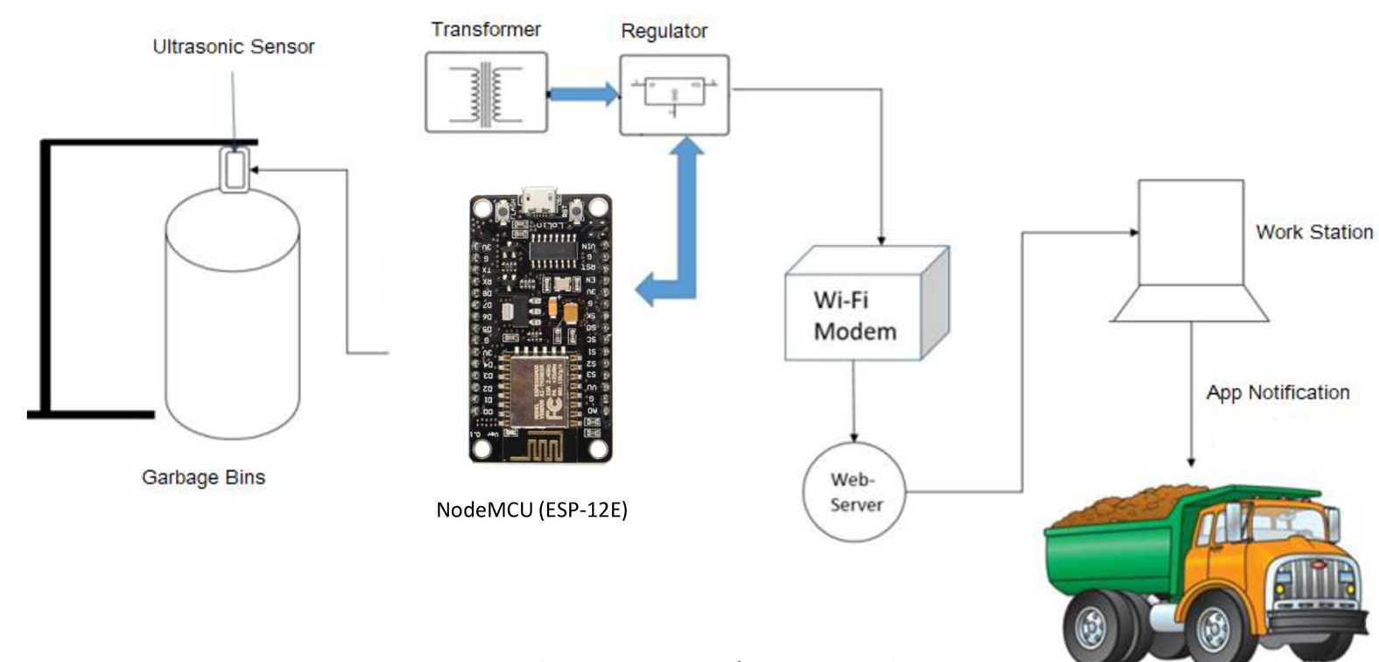

**Table-1 : Components & Technologies:**

|  |  |  |  |
| --- | --- | --- | --- |
| **S.No** | **Component** | **Description** | **Technology** |
|  | User Interface | Using a web UI, the user engages with the application | Android or ios app |
|  | Application Logic | The environment is written in **Java** and based on Processing and other open-source software | Java / Arduino |
|  | Database | The data obtained through the sensors installed in the trash can be transmitted to a MySQL database | MySQL |

**Table-2: Application Characteristics:**

| **S.No** | **Characteristics** | **Descrsiption** | **Technology** |
| --- | --- | --- | --- |
|  | Open-Source Frameworks | The Framework Directive sets the basic concepts and definitions related to waste management, including recycling and recovery | Java, MySQL |
|  | Security Implementations | It Alert when it is full | Smart Sensors |
|  | Scalable Architecture | Application server, Database server | NodeJS, MongoDB |
|  | Availability | The user can access through mobile application | Android or ios |
|  | Performance | Multiple user can access this through the application | WMS Components |

**References:**

[**https://www.nhp.gov.in/references-for-waste-management_pg**](https://www.nhp.gov.in/references-for-waste-management_pge)

[**https://aws.amazon.com/architecture**](https://aws.amazon.com/architecture)

[**https://medium.com/the-internal-startup/how-to-draw-useful-technical-architecture-diagrams-2d20c9fda90d**](https://medium.com/the-internal-startup/how-to-draw-useful-technical-architecture-diagrams-2d20c9fda90d)